DEPARTMENT OF ELECTRICAL AND ELECTRONICS ENGINEERING

4th NATIONAL LEVEL TECHNICAL SYMPOSIUM

RENOUVERZ 2K19
The Department of Electrical and Electronics Engineering, Adhi College of Engineering
Technology has organized 4th National Level Technical Symposium RENOUVERZ 2K19 on 07.08.2019. The agenda was to make students understand the nuances of planning and
organizing events and give them practical exposure to complement their academics. It was aimed
for the budding engineers to show case their talent and skills under a single roof and also to have
an opportunity to realize the hidden potential and competition among all the engineering students
across the country.

Inaugural Report:
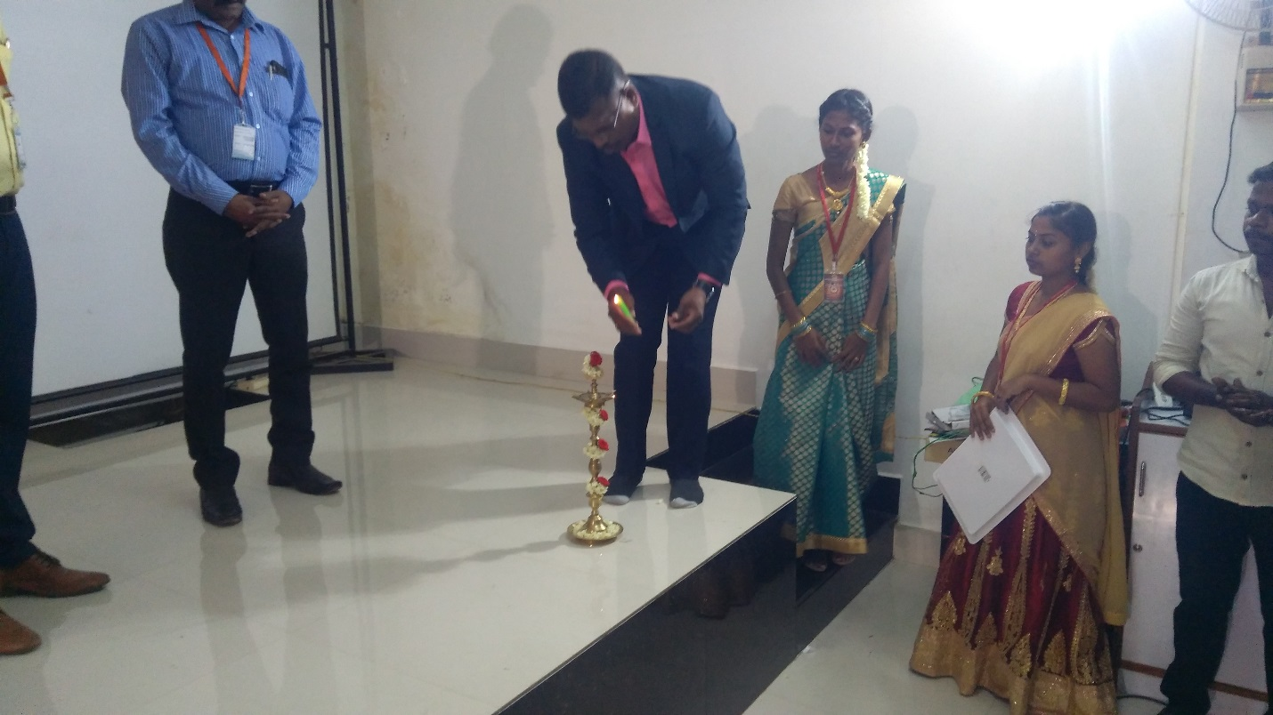

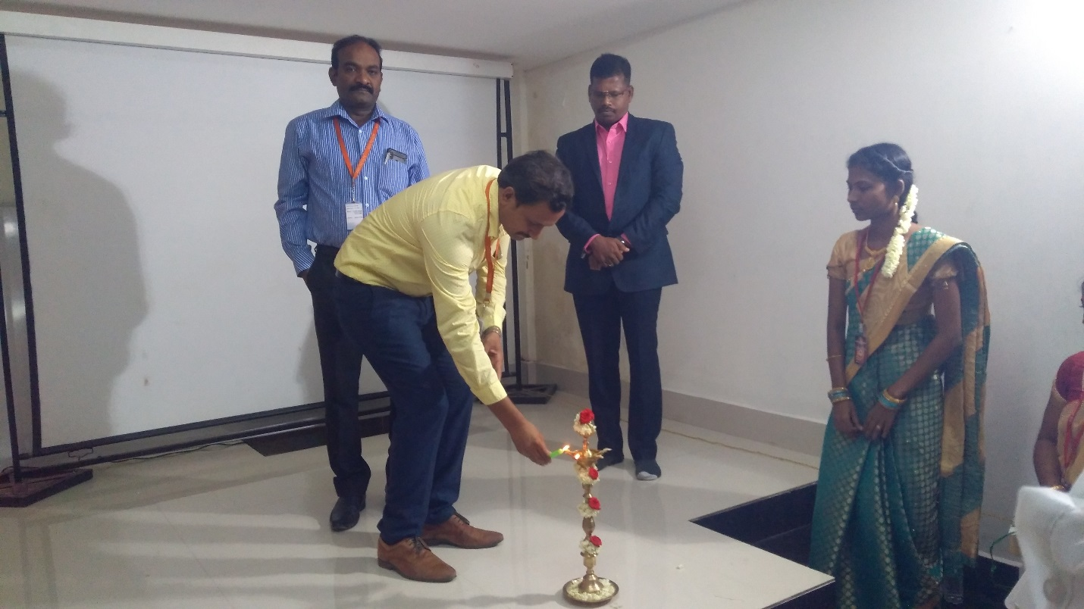
The 4th National Level Technical Symposium RENOUVERZ 2K19 was inaugurated by the Chief Guest of the day Dr.J.Balamurugan, Assistant Executive Engineer – TANGEDCO/TNEB, Dr.K.B.Bhasker, Head of the Department of EEE, Adhi college of engineering and Technology. The auspicious start of the day was marked by the traditional lighting of the lamp followed by the inaugural address.
In the Inaugural Speech, Our chief guest shared his views on the role of the educational institutes for the overall development of the engineering students so as to support the Industry and Corporate. With education increasingly becoming the primary determinant of overall development in the emerging knowledge economy. He gave valuable information to the students and motivated the students towards the industrial requirement of engineers by his inspirational address.
The faculty members, students from various colleges and all the dignitaries present gave a warm welcome to the chief guest and headed for a robust start.

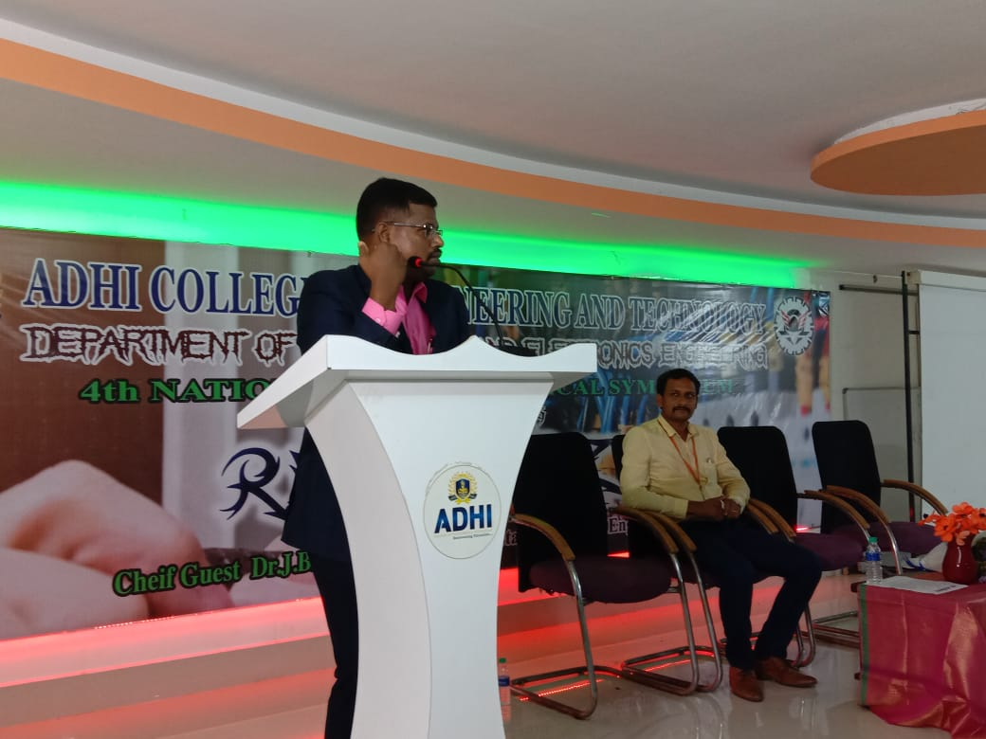
In seeking out with curious eye, the meat and bone of technology and innovation, the participants and the organizers learned the love underlying the challenge of engineering. The following were the events which provoked the interest of every individual present:
1. Paper Presentation: The event showcased the bright new ideas of budding engineers and their
future contributions to the world of technology.
2. Project Expo: This event gave the opportunity to bring the innovative ideas for the young minds to step into explore the technology.
3. Circuit Debugging: The event judged the students on their capability to understand the functions
of components in equipment’s and recreate it using their memory.
4. Technical Quiz: Riveting technical rounds, jumbles, rollover rounds and cryptic questions that
left the participants tizzy.
Apart from the Technical events, students participated eagerly in the Non – Technic events also:
- Box Cricket
- Junk Art
- Short Film
- Treasure Hunt
- PUBG
- Free Fire
- Dubstract
Valedictory Report:
More than 150 students from various reputed institutions like Rajalakshmi College of Engineering, Agni College of Engineering, IFET College of Engineering & Technology, Manakula Vinayagar Engineering College, SRM Valliammai Engineering College, University College of Engineering Kanchipuram, St.Joseph’s Engineering College, Sri Sairam Engineering College, KS Rangasamy College of Engineering, Adhi Parasakthi Engineering College, etc were participated in both Technical and Non – Technical events. 1st price in paper presentation and project expo was won by Agni College of Engineering, Second price in paper presentation was won by Manakula Vinayagar Engineering College and Second price in project expo was won by Adhi College of Engineering & Technology.
EVERY GOOD THING HAS TO COME TO AN END, SO DID RENOVERZ’2K19.
The 4th National Level Technical Symposium ended with the winners of all the competitions being
felicitated with awards and certificates followed by the vote of thanks speech by the Symposium Coordinator of RENOVERZ’2K19 Mr.R.Kumaresan, AP/EEE, Adhi college of engineering and Technology has set the bar for all National Symposia through RENOVERZ’2K19 by organizing it with utmost diligence and executing it with panache. The events not only piqued the interest of every individual present, but also left them riveted. The symposium provided the students a rostrum for innovation and the fortitude to think critically, plan, and execute and achieve.

PHOTO GALLERY:
